**KPI Modules based on KPI Categories**

The KPI table contains eleven records, classified by area of involvement. The first record is:

**1.KPI: Sahaaj Pathshalas**

|  |  |  |
| --- | --- | --- |
| **KPI** | **INPUT FILE** | **Dashboard data output within a given timeline** |
| No. of students | **888** | **For April,717**  **For May,171** |
| No. of tutors | **36** | **For April,36 tutors**  **For May,8 tutors** |
| No. of classrooms | **64** | **For April,64**  **For May,10** |
| % of senior classrooms (STD VI to STD X) | **47.7** | **For April,47.7**  **For May,40** |
| Number of students who passed class X | **Data unavailable** | **Data unavailable** |

**1.1: Workflow**

**Step 1: Tutor-level Inputs.** Each tutor enters their details, such as name, center, and class section, along with student attendance. This helps us:

Count unique tutors per month.

Identify the total number of students present in each classroom.

**Step 2: Classroom Configuration Centers are divided into sections: Junior, Senior, or Both. By filtering for “Senior” and “Both” (since “Both” includes senior classes too),**

we calculate:

The number of classrooms operating**.**

The percentage of senior classrooms relative to total entries**.**

**Step 3: Students & Results Tracking From the attendance entries:**

The Total number of Students is directly taken from the sheet under “Total number of students in the classroom”.

To find the No. of students who passed Class X, we plan to integrate a results file or create an additional column for recording pass percentages in the same form. This can be added as a remark or a new field.

**Step 4: Timeline & Automation.**

The responses come with a timestamp. Each row is automatically tagged with a month (like April or May). Using this, our dashboard updates month-wise trends such as:

Growth or drop in student strength

Tutor engagement

Classroom expansion

Senior-level focus

**Snapshot of Excel sheet**:

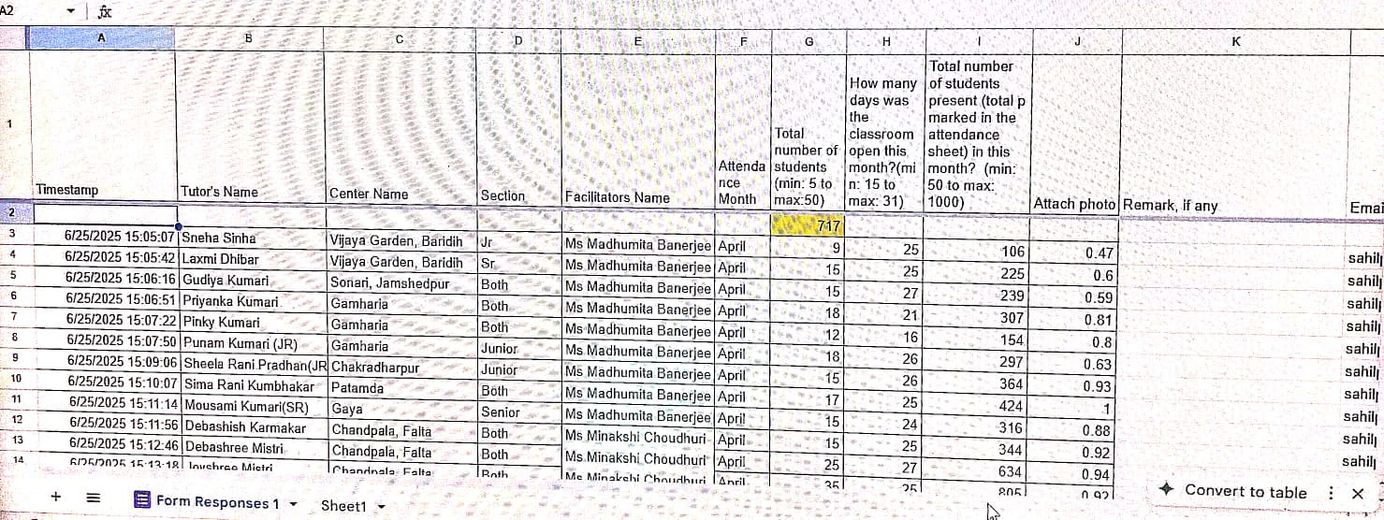

**KPI CALCULATION:**

**A. Number of Students**

Definition: The total count of students whose attendance is recorded.

Formula: Directly taken from the "Total number of students" column in the input sheet.

Input Source: The "Total number of students (min: 5 to max:50)" column in the attendance sheet.

**Calculation Logic**: Sum of unique student entries across all records for the specified month.

**B. Number of Tutors**

Definition: The count of unique tutors who have submitted attendance data.

Formula: Count of unique entries in the "Tutor's Name" column.

Input Source: The "Tutor's Name" column from the input sheet.

**Calculation Logic**: Count distinct values in "Tutor's Name" for the given month.

**C. Number of Classrooms**

Definition: The total count of operational classrooms.

Formula: Calculated by filtering for "Section" types "Junior," "Senior," or "Both".

Input Source: The "Section" column from the input sheet.

**Calculation Logic**: Count the number of distinct "Center Name" + "Section"

combinations that are operational for the month.

**D. Percentage of Senior Classrooms (STD VI to STD X)**

Definition: The proportion of senior-level classrooms relative to the total number of classrooms.

Formula: (Number of Senior Classrooms / Total Number of Classrooms) * 100.

Input Source: The "Section" column from the input sheet.

**Calculation Logic**: Filter for "Section" equal to "Senior" or "Both" to count senior classrooms. Divide this by the total number of classrooms (Junior, Senior, and Both combined) and multiply by 100.

**E. Number of students who passed Class X**

Definition: The count of students who successfully passed their Class X examinations.

Formula: This data is currently unavailable and will be integrated.

**1.2: Dashboard display**

The dashboard for **Sahaaj Pathshalas** captures key insights derived from attendance and classroom data for April and May. The display is designed to visually and analytically represent student engagement, tutor participation, and classroom utilization.

**Key Dashboard Elements**:

**Monthly Student Engagement Tracker**

A bar chart compares the number of students who attended sessions in April (717) and May (171), indicating a steep drop that needs attention.

**Tutor Deployment Pie Chart**

A pie chart reflects the availability of tutors (36 in April vs. 5 in May), giving a quick visual snapshot of human resource allocation.

**Classroom Utilization Overview**

A donut chart illustrates the total number of classrooms and the proportion that are senior-level (47.7% in April and 40% in May). This highlights a focus on higher grades.

KPI Summary Table

A clean, tabular summary of total students, tutors, classrooms, and percentage of senior classrooms, offering an at-a-glance understanding.